

//
mPoint
Overview
CellPoint Mobile
44 Wall Street, 12th floor
New York, NY 10005
USA

Phone: +1 212 461-7151
Fax: +1 212 461-2223
www.cellpointmobile.com
mPoint – Overview
1 Introduction 4
2 Background 5
3 Communicating with mPoint 7
3.1 Purchase API 7
3.2 Callback API 11
4 mPoint CSS Classes 13
5 mPoint Status Codes 14
Appendix A - Mobile Network Operators 17
Appendix B – Sample CSS file 19
Appendix C – Sample API Calls 22
Purchase API 22
Callback API 22

Terms & Definitions
Throughout the document, terms in bold are products and concepts such as “SMS Receipt” are quoted.
Additionally, the list below explains the different terms, which are used in several sections of this document:
SMS – Short Message Service
MO – Mobile Originated, a message, which has been sent FROM a mobile phone.
MT – Mobile Terminated, a message, which is being sent TO a mobile phone.
PMT – Premium MT, a message, which the end-user incurs a charge for receiving.
MSISDN - Mobile Subscriber ISDN Number, the End-User’s mobile number.
MCC – Mobile Country Code
IDC – International Dialling Code, the first 1 to 3 digits in a MSISDN, which indicates, which country the end-user is in.
Channel – The short code all messages are routed through.
Operator – The mobile network on, which the end-user is a subscriber.
MNC – Mobile Network Code for the Operator
Client – An external service / application that uses mPoint to process payments on the mobile phone.
Keyword – The first word in the MO message, which mPoint uses to determine the price for transactions instantiated via SMS.
End-user – A wireless subscriber from an operator who uses mPoint and thereby becomes a customer.

Introduction
This document will describe the API for Cellpoint Mobile’s cross payment solution: mPoint. mPoint acts as an intermediary between the client and an arbitrary number of clearance houses providing one united API for all payment transactions. Currently the following credit cards / payment systems are supported:
- American Express  - Dankort  - Diners Club | - EuroCard  - JCB  - Maestro | - MasterCard  - Visa  - Visa Electron
mPoint offers a secure method for communicating with both the client and the clearance houses using through HTTPS. This ensures that all end-user data is always encrypted using the newest Internet technology. The following diagram illustrates mPoint’s place in the infrastructure for credit card payments.
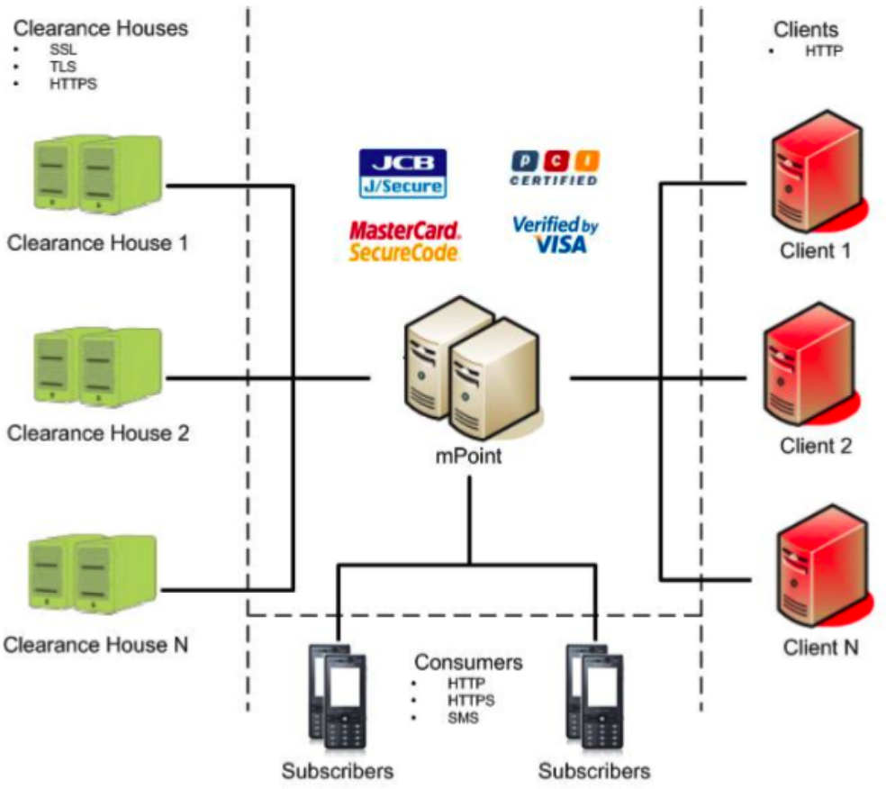
mPoint’s place in the “world” of credit card payment
In addition to aggregating the different interfaces for communicating with a range of clearance houses, mPoint implements the Business Logic necessary to ensure that consumers are never “lost” while making a payment on the mobile phone. Through mPoint’s SurePayTM technology consumers are guided through the payment process and customer service is automatically notified if the customer needs assistance in completing the payment.

Background
mPoint has been designed to process credit card payments in a variety of scenarios including:
- Instant purchase via SMS in response to Billboard / TV / Radio advertisement
- Phone sale through Call Centres
- Purchases of Mobile Applications
- M-Commerce from Mobile Internet Sites
Additionally mPoint can be combined with purchase recommendations upon completion of the payment thereby creating new up selling opportunities for the client. All interaction between the customer and mPoint takes place on the customer’s mobile phone. This allows clients to reach consumers anytime, anywhere!
The diagram below illustrates the payment process in each of the listed scenarios.
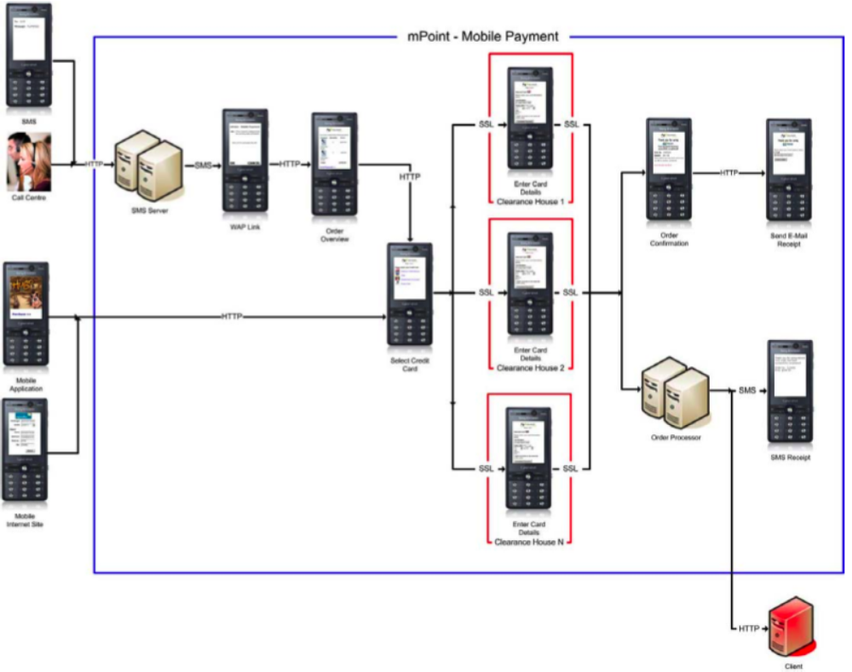
mPoint payment process
The payment process illustrated by the diagram above can be broken into the following steps:
- The Customer sends an MO-SMS in response to the advertisement
- mPoint sends an MT-SMS with a WAP link for processing the payment
- The customer actives the link in order to access the order overview page
- The customer selects “Go to Payment” if the overview is acceptable
- The customer selects his Credit Card
- mPoint routes the payment information to the clearance house
- The customer enters his credit card details
- The clearance house returns the customer to mPoint:
  - mPoint presents the customer with an order confirmation page
  - mPoint receives the payment status from the clearance house and completes the order processing:
    - mPoint sends an “SMS Receipt” to the customer with the order details
    - mPoint sends the payment status to the client’s back office
- From the order confirmation page the customer can optionally:
  - Access another mPoint page where he can enter his e-mail address to receive a receipt via e-mail
  - Access a Mobile Internet Site created by the client, which presents additional purchase recommendations to create up selling opportunities.
Please note, step 1 is only applicable for purchases initiated via SMS and steps 2 to 4 are only applicable in scenarios where the customer is making the purchase via SMS or through Phone Sale. Also all communication with the customer is automatically encrypted by the Mobile Operator Networks using their respective proprietary encryption algorithms. Additionally all communication with the clearance house that processes the customer’s credit card details are encrypted using standard SSL technology. This approach ensures that mPoint is at least as secure as any existing E-Commerce site such as Amazon.
In order to use mPoint, the client must have an agreement in place with one or more clearance houses as mPoint uses their existing infrastructure for processing and clearing the customer’s credit card.
Cellpoint Mobile recommends using DIBS – Payment Services for all mPoint initiatives in Europe. DIBS have proven themselves as a reliable partner with a sophisticated platform, which includes advanced security modules to detect and prevent credit card fraud.

Communicating with mPoint
mPoint offers 2 APIs to accommodate the a one time purchase and a recurring subscription.
Each of these APIs have 3 parts:
- Call Centre API
- Mobile Internet API
- SMS API
Each part of the 2 APIs are described in more detail in this section.

Purchase API
The Purchase APIs provides the client with a simple and convenient mean of offering customers to complete one time purchases such as buying a book, a CD or a washing machine from different sources. Each part of the Purchase API can be accessed at http://mPoint.cellpointmobile.com/buy/

Call Centre API
mPoint’s Call Centre API is used for payment transactions where the customer receives an SMS with a link for accessing mPoint. This approach is used in the following scenarios:
- Phone sale through Call Centres
The API is available at http://mpoint.cellpointmobile.com/buy/callcentre.php and accepts the parameters described by the table below via HTTP POST.
Please note that all parameters are lowercase and must be URL encoded prior to being passed to mPoint.
Data field | Type | M/O* | Description
clientid | Integer | M | Client’s unique ID for mPoint
account | Integer | O | ID or Number for the sub-account that the payment transaction should be associated with. Account ID is an integer greater than 100000 and Account Number is an integer smaller than 1000.  The payment transaction will be associated with the default sub-account if this parameter is omitted.
orderid | String | O | Client’s Order ID for the transaction.
mobile | Integer | M | MSISDN of the customer without International Dialling Code
operator | Integer | O | ID of the customer’s Mobile Network Operator, it is recommended to include this parameter in the request to ensure that mPoint correctly interacts with the Operator.  Please refer to Appendix A – Mobile Network Operators for details on this parameter.
email | String | O | The customer’s e-mail address (if available). If this parameter is provided, the E-Mail input field on the “Send E-Mail Receipt” page is automatically pre-populated with this value.
prod-names** | Array | M | Name of each product being sold to the customer.  This parameter is used to generate the order overview page for the customer.
prod-quantities** | Array | M | Number of items of each product being sold.  This parameter is used to generate the order overview page for the customer.
prod-prices** | Array | M | Total price for the product being sold.  This parameter is used to generate the order overview page for the customer.  The total amount that the customer should be charged for the payment transaction will be calculated based on this. The price for each product must be in the country’s smallest currency.
prod-logos** | Array | O | Absolute URL to the product’s logo in 40x40 pixel.  This parameter is used to generate the order overview page for the customer.  mPoint will use a default image if this parameter is omitted.
language | String | O | The language that mPoint should use as the default when translating the payment pages. mPoint will determine the language using the following steps:  - Analyse the HTTP Header: Accept-Language provided by the customer's browser  - Use the content of the language parameter  - Use the client’s default language  - Use the default system language: British English (gb)  mPoint will use the client’s default language if this parameter is omitted.  Currently mPoint supports the following languages:  Currently mPoint supports the following languages:  mPoint language codes are based upon the ISO-639-1 standard, please refer to http://en.wikipedia.org/wiki/List_of_ISO_639-1_codes for details.
  Value | Language
  us | American English
  gb | British English
  da | Danish
  sv | Swedish
css-url | String | O | Absolute URL to the custom stylesheet file mPoint should use for customising the look and feel of the payment pages to match the client’s theme.  Please refer to section 4: mPoint CSS Classes for details on the classes used by mPoint in each instance.  mPoint will use the client’s default URL if this parameter is omitted.
logo-url | String | O | Absolute URL to the client’s logo which mPoint should display on all payment pages. The logo will be resized to have a max width of the screen width of the customer’s mobile phone and a max height of 20% of the mobile phone’s screen height.  It is recommended that the logo is a rectangle with a greater width than height.  mPoint will use the client’s default URL if this parameter is omitted.
accept-url | String | O | Absolute URL where mPoint should direct the customer to upon having successfully completed the payment transaction.  mPoint will use the client’s default URL if this parameter is omitted.
cancel-url | String | O | Absolute URL where mPoint should direct the customer to in case he cancels the payment transaction midway.  mPoint will use the client’s default URL if this parameter is omitted.
callback-url | String | O | Absolute URL to the client’s back office where mPoint should send the payment status to.  Please refer to section 5: mPoint Status Codes for details.  mPoint will use the client’s default URL if this parameter is omitted.
return-url | String | O | Absolute URL where mPoint should redirect the Phone Operator to when the request has been processed. If this parameter is used, mPoint will append all status codes to the URL as HTTP GET parameters as an array of codes named “msg”. In this case it’s up to the client to create a status page for the phone operator.  Please refer to section 5: mPoint Status Codes for details.  mPoint will generate a status page in XHTML format if this parameter is omitted.
var_XXX | String | O | Any variable with the “var_” prefix will be returned to the client upon completion of the payment transaction. Thus the following URLs will receive these parameters as HTTP POST:  - accept-url  - cancel-url  - callback-url
* Mandatory / Optional
** The array key for each of these parameters MUST match

Mobile Internet API
mPoint’s Mobile Internet API is used for payment transactions where the customer is already on an external mobile internet site and mPoint is simply used for processing the payment. This approach is used in the following scenarios:
- Purchases of Mobile Applications
- M-Commerce from Mobile Internet Sites
The API is available at http://mpoint.cellpointmobile.com/buy/web.php and accepts the parameters described by the table below via HTTP POST.
Please note that all parameters are lowercase and must be URL encoded prior to being passed to mPoint.
Data field | Type | M/O* | Description
clientid | Integer | M | Client’s unique ID for mPoint
account | Integer | O | ID or Number for the sub-account that the payment transaction should be associated with. Account ID is an integer greater than 100000 and Account Number is an integer smaller than 1000.  The payment transaction will be associated with the default sub-account if this parameter is omitted.
orderid | String | O | Client’s Order ID for the transaction.
mobile | Integer | M | MSISDN of the customer without International Dialling Code
operator | Integer | O | ID of the customer’s Mobile Network Operator, it is recommended to include this parameter in the request to ensure that mPoint correctly interacts with the Operator.  Please refer to Appendix A – Mobile Network Operators for details on this parameter.
email | String | O | The customer’s e-mail address (if available). If this parameter is provided, the E-Mail input field on the “Send E-Mail Receipt” page is automatically pre-populated with this value.
amount | Integer | M | Total amount that the customer should be charged for the payment transaction in country’s smallest currency.
language | String | O | The language that mPoint should use as the default when translating the payment pages. mPoint will determine the language using the following steps:  - Analyse the HTTP Header: Accept-Language provided by the customer's browser  - Use the content of the language parameter  - Use the client’s default language  - Use the default system language: British English (gb)  mPoint will use the client’s default language if this parameter is omitted.  Currently mPoint supports the following languages:  mPoint language codes are based upon the ISO-639-1 standard, please refer to http://en.wikipedia.org/wiki/List_of_ISO_639-1_codes for details.
  Value | Language
  us | American English
  gb | British English
  da | Danish
  sv | Swedish
css-url | String | O | Absolute URL to the custom stylesheet file mPoint should use for customising the look and feel of the payment pages to match the client’s theme.  Please refer to section 4: mPoint CSS Classes for details on the classes used by mPoint in each instance.  mPoint will use the client’s default URL if this parameter is omitted.
logo-url | String | O | Absolute URL to the client’s logo which mPoint should display on all payment pages. The logo will be resized to have a max width of the screen width of the customer’s mobile phone and a max height of 20% of the mobile phone’s screen height.  It is recommended that the logo is a rectangle with a greater width than height.  mPoint will use the client’s default URL if this parameter is omitted.
accept-url | String | O | Absolute URL where mPoint should direct the customer to upon having successfully completed the payment transaction.  mPoint will use the client’s default URL if this parameter is omitted.
cancel-url | String | O | Absolute URL where mPoint should direct the customer to in case he cancels the payment transaction midway.  mPoint will use the client’s default URL if this parameter is omitted.
callback-url | String | O | Absolute URL to the client’s back office where mPoint should send the payment status to.  Please refer to section 5: mPoint Status Codes for details.  mPoint will use the client’s default URL if this parameter is omitted.
var_XXX | String | O | Any variable with the “var_” prefix will be returned to the client upon completion of the payment transaction. Thus the following URLs will receive these parameters as HTTP POST:  - accept-url  - cancel-url  - callback-url
* Mandatory / Optional

SMS API
mPoints SMS API is quiet different from the 2 APIs previously described. This approach is used in the following scenarios:
- Instant purchase via SMS in response to advertisement via:
  - Billboard
  - Radio
  - TV
The client should never call this API directly but rather a keyword must be configured in mPoint, which triggers an SMS link to the customer for accessing mPoint. This approach allows a customer to make a purchase by simply sending an SMS message to one of Cellpoint Mobile’s short codes. For each keyword used in this way one or more products must be added in mPoint allowing the customer with a convenient and simple mean to make a predefined purchase.
For each product the following data fields described by the following table must be configured.
Data field | Type | M/O* | Description
name | String | M | Name of the product being sold to the customer.  This field is used to generate the order overview page for the customer.
quantity | Integer | M | Number of items of the product being sold.  This field is used to generate the order overview page for the customer.
price | Integer | M | Total price for the product being sold.  This field is used to generate the order overview page for the customer.  The total amount that the customer should be charged for the payment transaction will be calculated based on this. The price for the product must be in the country’s smallest currency.
logo | String | O | Absolute URL to the product’s logo in 40x40 pixel.  This field is used to generate the order overview page for the customer.  mPoint will use a default image if this field is omitted.
* Mandatory / Optional
In addition to the data fields described the table above, the SMS API will use the client defaults for the following optional parameters described in the Call Centre and Mobile Internet API:
- logo-url
- css-url
- accept-url
- cancel-url
- callback-url
- language
The recipient and operator are both determined from the received SMS.

Callback API
When mPoint has completed processing a transaction, the system can create a callback to the client as an HTTP POST request to notify the client of the payment status. This request will always originate from the IP of mpoint.cellpointmobile.com.
The callback will include the parameters described by the table below.
Please note that all parameters are lowercase and will be URL encoded prior to being passed to the client.
Data field | Type | M/O* | Description
mpoint-id | Integer | M | mPoint’s unique ID for the payment transaction.
orderid | Integer | M | The Order ID provided by the client upon instantiating the transaction.
status | Integer | M | An integer code indicating the status of the transaction. Please refer to the next table for details on the possible status codes.
amount | Integer | M | Total amount that the customer was charged for the payment transaction in country’s smallest currency.
currency | String | M | The currency that the customer was charged in.
mobile | String | M | MSISDN of the customer without International Dialling Code
operator | Integer | M | ID of the customer’s Mobile Network Operator.  Please refer to Appendix A – Mobile Network Operators for details on this parameter.
var_XXX | Mixed | O | Any custom variables passed to mPoint when the payment transaction was instantiated.
* Mandatory / Optional
The table below describes the status codes, which may be received from mPoint to indicate the status of a payment transaction:
Code | Type | Description
2000 | Success | Payment has been successfully cleared by the Payment Service Provider
2001 | Error | Payment was declined by the Payment Service Provider

mPoint CSS Classes
mPoint offers several style sheet classes through which a client can control the look and feel of the payment flow. The most important CSS classes are described in the table below, please refer to Appendix B – Sample CSS file for a complete list of classes.
Class | Type | Description
body, table, div | Tag | Styles defined for each of these tags will affect the general look and feel for every page. mPoint uses validated XHTML Mobile 1.0 markup for all pages each of which generally contains both div and table tags.
h1 | Tag | Controls the look of the headline on the pages after payment have been successfully completed.
a, a:hover | Tag | Controls the look and behaviour of all links.
mPoint_Label | Class | Is used for all labels and captions throughout mPoint such as column headings, labels for input fields etc.
mPoint_Info | Class | Is used for displaying general information to the end-user such as the payment progress, help messages etc.
mPoint_Status | Class | Is used when mPoint displays status messages to the end-user such as failed input validation, failed lookup etc.
td.mPoint_Number | Class | Is used to control how mPoint displays prices
tr.mPoint_Even | Class | Is used to control the look of even row numbers in listings
tr.mPoint_Uneven | Class | Is used to control the look of uneven row numbers in listings
input.mPoint_Button | Class | Is used to control the look of form buttons
input.mPoint_Card_Button | Class | Is used to control the look for the form buttons when listing the available credit cards.
table#products | Id | Is used when displaying products
table#receipt | Id | Is used when displaying the payment receipt to the end-user after payment has been successfully completed.
div#logo | Id | Is used to control how the client logo is displayed and placed on each page.
div#progress | Id | Is used to control how status progression is displayed and placed on each page.
div#mPoint | Id | Is used to control how the mPoint logo is displayed and placed on each page.
div#status | Id | Is used when mPoint displays the payment status to the end-user
div#terms | Id | Is used to control how the client’s Terms & Conditions will be displayed
div#delivery | Id | Is used to control how the delivery information for Physical Sales are displayed
div#shipping | Id | Is used to control how the shipping information for Physical Sales are displayed
div#email | Id | Is used to control how the input form when sending an e-mail receipt is displayed
div#cardinfo | Id | Is used to control how the input form where the customer enters his credit card information is displayed
input.number | Class | Is used to control the behaviour for input fields, which should only accept numbers such as the credit card number, expiry date, CVC.  This style should ALWAYS include: -wap-input-format: '*N'; to specify that only numbers can be input.

mPoint Status Codes
When receiving a payment request from a client mPoint will perform extensive validation of the received data in order to ensure that the payment pages will be rendered correctly on the end-user’s mobile device and the transaction have the greatest chance of succeeding when being sent to the PSP for clearance.
To simplify the process of determining mPoint’s response to the message request, mPoint will set the HTTP Response code as defined by the table below:
HTTP Code | mPoint Response
200 | Payment request has been validated successfully and accepted by mPoint
400 | Payment request has been rejected by mPoint due to a validation error
403 | Client authentication failed
415 | Message was transmitted in an unknown format or using an unsupported Content Type
In addition to the HTTP Response code, mPoint will return one or more status codes along with a description of each code. This allows the client to solve all errors before the next request attempt thereby preventing needless communication with mPoint.
The following table offers a complete list of all possible status codes, which mPoint may respond with:
Code | Type | Description
1000 | Success | Payment Transaction has been successfully initialised
11 | Error | Undefined Client ID
12 | Error | Invalid Client ID
13 | Error | Unknown Client ID
14 | Error | Client Disabled
21 | Error | Undefined Account
22 | Error | Invalid Account
23 | Error | Unknown Account ID
24 | Error | Account Disabled
31 | Error | Undefined Recipient
32 | Error | Recipient is too short
33 | Error | Recipient is too long
41 | Error | Undefined Operator ID
42 | Error | Operator ID is too short
43 | Error | Operator ID is too big
51 | Error | Undefined Amount
52 | Error | Amount is too small, amount must be greater than 1 (0,01 of the country's currency)
53 | Error | Amount is too great, amount must be smaller than the max amount specified by the client
61 | Error | Undefined Product Names (array size = 0)
62 | Error | Undefined Product Quantities (array size = 0)
63 | Error | Undefined Product Prices (array size = 0)
64 | Error | Invalid Arrays sizes (the 3 arrays differs in size)
65 | Error | Array key not found in Product Quantities
66 | Error | Array key not found in Product Prices
67 | Error | Invalid URL found in array of Logo URLs
71 | Error | Undefined Logo URL
72 | Error | Logo URL is too short, min length is 11 characters
73 | Error | Logo URL is too long, max length is 255 characters
74 | Error | Logo URL is malformed
75 | Error | Logo URL is Invalid, no Protocol specified
76 | Error | Logo URL is Invalid, no Host specified
77 | Error | Logo URL is Invalid, no Path specified
81 | Error | Undefined CSS URL
82 | Error | CSS URL is too short, min length is 11 characters
83 | Error | CSS URL is too long, max length is 255 characters
84 | Error | CSS URL is malformed
85 | Error | CSS URL is Invalid, no Protocol specified
86 | Error | CSS URL is Invalid, no Host specified
87 | Error | CSS URL is Invalid, no Path specified
91 | Error | Undefined Accept URL
92 | Error | Accept URL is too short, min length is 11 characters
93 | Error | Accept URL is too long, max length is 255 characters
94 | Error | Accept URL is malformed
95 | Error | Accept URL is Invalid, no Protocol specified
96 | Error | Accept URL is Invalid, no Host specified
97 | Error | Accept URL is Invalid, no Path specified
101 | Error | Undefined Cancel URL
102 | Error | Cancel URL is too short, min length is 11 characters
103 | Error | Cancel URL is too long, max length is 255 characters
104 | Error | Cancel URL is malformed
105 | Error | Cancel URL is Invalid, no Protocol specified
106 | Error | Cancel URL is Invalid, no Host specified
107 | Error | Cancel URL is Invalid, no Path specified
111 | Error | Undefined Callback URL
112 | Error | Callback URL is too short, min length is 11 characters
113 | Error | Callback URL is too long, max length is 255 characters
114 | Error | Callback URL is malformed
115 | Error | Callback URL is Invalid, no Protocol specified
116 | Error | Callback URL is Invalid, no Host specified
117 | Error | Callback URL is Invalid, no Path specified
121 | Error | Undefined Return URL
122 | Error | Return URL is too short, min length is 11 characters
123 | Error | Return URL is too long, max length is 255 characters
124 | Error | Return URL is malformed
125 | Error | Return URL is Invalid, no Protocol specified
126 | Error | Return URL is Invalid, no Host specified
127 | Error | Return URL is Invalid, no Path specified
131 | Error | Undefined Language
132 | Error | Invalid Language, language contains invalid characters which are NOT a-z or _
133 | Error | Language not supported
142 | Error | E-Mail address is too short, min length is 4 characters
143 | Error | E-Mail address is too long, max length is 50 characters
144 | Error | E-Mail address contains invalid characters which are NOT a-z 0-9 A-Z æ ø å Æ Ø Å _ @ . or -
145 | Error | E-Mail address has an invalid format, a valid e-mail address MUST be in the format: {NAME}@{DOMAIN}.{TOP DOMAIN}, i.e. support@cellpointmobile.com
1001 | Error | Internal Database Error - Unable to generate new Transaction ID. Please contact support@cellpointmobile.com
1002 | Error | Internal Database Error - Unable to create a new Transaction. Please contact support@cellpointmobile.com
1003 | Error | Internal Database Error - Unable to insert new message for Transaction. Please contact support@cellpointmobile.com
1004 | Error | Internal Database Error - Unable to update Transaction. Please contact support@cellpointmobile.com
1011 | Error | Mobile Network Operator not supported
1012 | Error | Internal Communication Error - Message rejected by GoMobile. Please contact support@cellpointmobile.com
1013 | Error | Internal Communication Error - Unable to connect to GoMobile. Please contact support@cellpointmobile.com
1021 | Error | Configuration Error - No Shop Configuration found for Client

Appendix A - Mobile Network Operators
In each country available through GoMobile, several Operator Networks exists. The client should always attempt to provide the correct Operator ID for the end-user to ensure that GoMobile can take any operator specific behaviour into account when transmitting the MT-SMS to the network.
The “unknown” operator option should only be used if the Operator Network for the recipient is in fact not known or after consulting with Cellpoint Mobile.

Denmark
ID | Operator
10000 | Unknown
10001 | TDC
10002 | Telia
10003 | Orange*
10004 | Sonofon
10005 | Tele2**
10006 | 3
* Orange was purchased by Telia in 2003 and the Operator Network doesn’t exist anymore in a physical sense as all wireless subscribers from Orange have been moved to Telia.
** Tele2 was purchased by Sonofon in 2008 and the Operator Network doesn’t exist anymore in a physical sense as all wireless subscribers from Tele2 have been moved to Sonofon.

Sweden
ID | Operator
10100 | Unknown
10101 | Telia
10102 | Telenor
10103 | 3
10104 | Tele2

Norway
ID | Operator
10200 | Unknown
10201 | Telenor
10202 | Netcom
10203 | Ventelo
10204 | Tele2

United Kingdom
ID | Operator
10300 | Unknown
10301 | O2
10302 | Vodafone
10303 | 3
10304 | T-Mobile
10305 | Virgin Mobile
10306 | Orange
10307 | Jersey Telecom
10308 | Cable & Wireless

Finland
ID | Operator
10400 | Unknown
10401 | Sonera
10402 | DNA
10403 | Elisa
10404 | Saunalahti
10405 | Tele Finland
10406 | AMT

USA
ID | Operator
20000 | Unknown
20001 | AT&T Mobility*
20002 | T-Mobile
20003 | Verizon Wireless
20004 | Sprint
20005 | Nextel**
20006 | Boost**
20007 | Alltel
20008 | Cellular One***
20009 | Virgin Mobile
20010 | US Cellular
20011 | Boost Unlimited
* AT&T Mobility is the result of Cingular Wireless’ purchase of the old AT&T Wireless in 2004. In 2006 AT&T bought Bellsouth, which owned Cingular Wireless and created AT&T Mobility from the old Cingular Orange network, which was the result of all Cingular Wireless and AT&T Wireless subscribers.
** Sprint bought Nextel and Boost in 2005, the network technologies used are vastly different though and it is therefore expected that moving all subscribers onto one network is a time consuming process.
*** Cellular One was formerly known as Dobson and has recently been acquired by AT&T Mobility. It is expected that all subscribers will be moved to AT&T Mobility.

Appendix B – Sample CSS file
The sample CSS file in this section will be used by mPoint by default if no css-url has been specified when the payment transaction was instantiated and no default css-url has been configured for the client.
Please refer to section 4: mPoint CSS Classes for details.
/* ========== Tag Classes Start ========== */
body
{
margin: 0px 5px 0px 5px;
}
body, table
{
background-color: #fff;
text-align: left;
}
body, table, div
{
font-size: 1em;
font-family: "Trebuchet MS",arial,sans-serif;
color: #000;
}

h1
{
font-size: 130%;
white-space: nowrap;
text-align: center;
color: #000;
}

form, table
{
margin: 0px 0px 0px 0px;
padding: 0px 0px 0px 0px;
}

a
{
color: blue;
text-decoration: none;
}

a:hover
{
text-decoration: underline;
}

input.number
{
-wap-input-format: '*N';
}
/* ========== Tag Classes End ========== */

/* ========== mPoint Classes Start ========== */
.mPoint_Label
{
font-weight: bold;
padding-right: 0.5em;
padding-top: 0.3em;
}

.mPoint_Info
{
font-weight: normal;
font-style: italic;
color: #000;
text-align: left;
padding: 0px;
margin: 0px;
}

.mPoint_Status
{
color: red;
font-style: italic;
padding-top: 0.5em;
padding-bottom: 0.5em;
}

td.mPoint_Number
{
padding-right: 0.5em;
text-align: right;
vertical-align: bottom;
}

tr.mPoint_Even, div.mPoint_Even
{
}
tr.mPoint_Uneven, div.mPoint_Uneven
{
background-color: #E0E0E0;
}

input.mPoint_Button
{
font-weight: bold;
border-color: #6DAADD;
background-color: #6c8ca3;
}

input.mPoint_Card_Button
{
border-style: none;
background-color: #fff;
color: blue;
text-decoration: underline;
margin: 0px 0px 0px 0px;
padding: 0px 0px 2px 0px;
}
/* ========== mPoint Classes Start ========== */

/* ========== ID Classes Start ========== */
table#products tr td
{
padding-left: 3px;
padding-top: 3px;
}

table#receipt
{
background-color: #E0E0E0;
margin-top: 0.5em;
margin-bottom: 0.5em;
}

div#logo, div#progress, div#mPoint, div#status
{
text-align: center;
}

div#status table tr td
{
vertical-align: middle;
padding-left: 0.5em;
}

div#terms
{
white-space: pre;
}

div#delivery, div#email, div#cardinfo
{
background-color: #E0E0E0;
padding-left: 3px;
padding-bottom: 3px;
}
div#shipping div table tr td
{
padding-top: 3px;
padding-left: 3px;
}
/* ========== ID Classes End ========== */

Appendix C – Sample API Calls
The code snippets in this section provide examples of how mPoint can be integrated with each of the APIs available to clients.
Please refer to section 3: Communicating with mPoint for details on the data fields in each example.

Purchase API

Call Centre API
<form action="http://mpoint.cellpointmobile.com/buy/callcentre.php" method="post">
<input type="hidden" name="clientid" value="10000" />
<input type=“hidden” name="account" value="-1" />
<input type="hidden" name="recipient" value="12345678" />
<input type="hidden" name="operator" value="10000" />
<input type=“hidden” name="email" value="support@cellpointmobile.com" />
<input type="hidden" name="prod-names[test]" value="Test Product" />
<input type="hidden" name="prod-quantities[test]" value="3" />
<input type="hidden" name="prod-prices[test]" value="100" />
<input type="hidden" name="prod-logos[test]" value="http://demo.ois-inc.com/mPoint/_test/product_logo.jpg" />
<input type="hidden" name="language" value="da" />
<input type="hidden" name="logo-url" value="http://demo.ois-inc.com/mPoint/_test/client_logo.jpg" />
<input type="hidden" name="css-url" value="http://demo.ois-inc.com/mPoint/_test/styles.css" />
<input type="hidden" name="accept-url" value="http://demo.ois-inc.com/mPoint/_test/accept.php" />
<input type="hidden" name="cancel-url" value="http://demo.ois-inc.com/mPoint/_test/cancel.php" />
<input type="hidden" name="callback-url" value="http://demo.ois-inc.com/mPoint/_test/callback.php" />
<input type="hidden" name="orderid" value="123abc" />
<input type="hidden" name="var_test" value="Test Variable" />
<input type="submit" value="Send" />
</form>

Mobile Internet API
<form action="http://mpoint.cellpointmobile.com/buy/web.php" method="post">
<input type=“hidden” name="clientid" value="10000" />
<input type=“hidden” name="account" value="-1" />
<input type=“hidden” name="mobile" value="12345678" />
<input type=“hidden” name="operator" value="10000" />
<input type=“hidden” name="email" value="support@cellpointmobile.com" />
<input type=“hidden” name="amount" value="100" />
<input type=“hidden” name="language" value="da" />
<input type=“hidden” name="logo-url" value="http://demo.ois-inc.com/mPoint/_test/client_logo.jpg" />
<input type=“hidden” name="css-url" value="http://demo.ois-inc.com/mPoint/_test/styles.css" />
<input type=“hidden” name="accept-url" value="http://demo.ois-inc.com/mPoint/_test/accept.php" />
<input type=“hidden” name="cancel-url" value="http://demo.ois-inc.com/mPoint/_test/cancel.php" />
<input type=“hidden” name="callback-url" value="http://demo.ois-inc.com/mPoint/_test/callback.php" />
<input type=“hidden” name="orderid" value="123abc" />
<input type=“hidden” name="var_test" value="Test Variable" />
<input type="submit" value="Send" />
</form>

Callback API
POST {PATH FROM CALLBACKURL} HTTP/1.0
Host: {HOST FROM CALLBACKRUL}
Referer: mpoint.cellpointmobile.com/callback/dibs.php
User-Agent: mPoint
Content-Length: 122
Content-Type: application/www-url-form-encoded; charset=ISO-8859-15

mpoint-id=123456&
orderid=123abc&
status=2000&
amount=100&
currency=DKK&
mobile=12345678&
operator=10000&
var_test=Test+Variable

